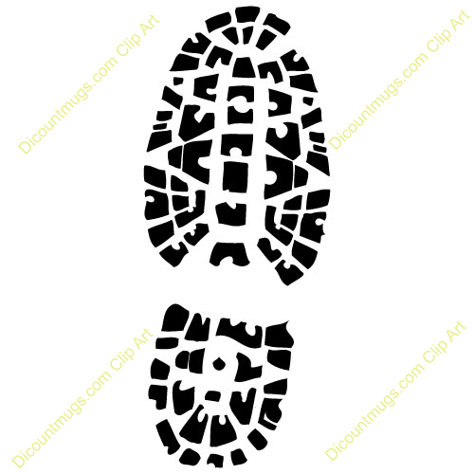
I used ___________________ to measure this print. It is _____ ____________________ long.

I also used ________________ to measure this print. It is ______ ____________________ long.

